
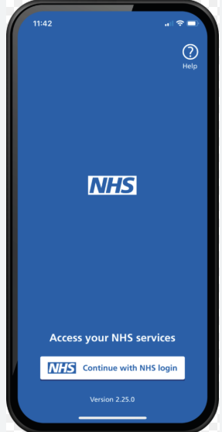

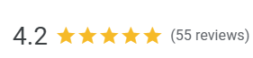

PARK END SURGERY NEWSLETTER FEB 2026
MISSED
APPOINTMENTS
We understand that sometimes plans
change. If you’re unable to attend
your appointment, please let us know
as soon as possible by giving us a call.
This allows us to offer the slot to
another patient in need.
You can also cancel your
appointment online
through your NHS app.

Extended Services Out of Hours
Our practice offers extended access outside regular hours. For medical assistance when we’re closed, call 020 7428 5701.
Monday–Friday: 6:30pm–8:00pm
Saturday: 9:00am–5:00pm
Provided by Camden Health Partners at:
Hampstead Group Practice – 75 Fleet Road, NW3 2QU
Parliament Hill Medical Centre – 113–117 Highgate Road, NW5 1TR
Caversham Group Practice – 4 Peckwater Street, NW5 1UP

New Practice Staff
We’re pleased to welcome our new Doctor Registrars, fully qualified doctors completing 6–12-month placements in General Practice:
- Dr Sultan Farooq
- Dr Charlie Thurston

We value your feedback,
Tell us how we did, leave a quick Google review. Just scan the QR code.

🕒 Our Opening Times
Day | Surgery Opening | Reception / Phone Lines
Monday | 08:00 – 18:30 | 08:00 – 18:30
Tuesday | 08:00 – 18:30 | 08:00 – 18:30
Wednesday | 08:00 – 18:30 | 08:00 – 18:30
Thursday | 08:00 – 18:30 | 08:00 – 18:30
Friday | 08:00 – 18:30 | 08:00 – 18:30
Saturday | Closed | Closed
Sunday | Closed | Closed

Patient Participation Group (PPG)
The PPG is a group of patients working with the practice to improve services. Meeting three times a year, they act as a link between patients and the practice. Your feedback is valued and helps shape care, even if not every suggestion can be implemented.
PPG Aims:
- Provide feedback and ideas to enhance the practice
- Share patient experiences
- Support development of new services
- Improve healthcare provision

Online Platforms
Booking appointments can be easier using the NHS App, where you can also request prescription refills. You can also contact us via the eConsult platform on our website.

